Using extracts to minimize the amount of data your computer is processing at a time can vastly improve performance. While filters within worksheets and dashboards have to be queried each time you update your data/parameters, filters added in an extract are queried once and then persist after any further updates to your worksheets. Filtering your extracts by a date and time range is the easiest way to do this while still having a productive test environment. For this example I’ll be showing you how to this and how to filter data by measurement.

Go to the data source tab: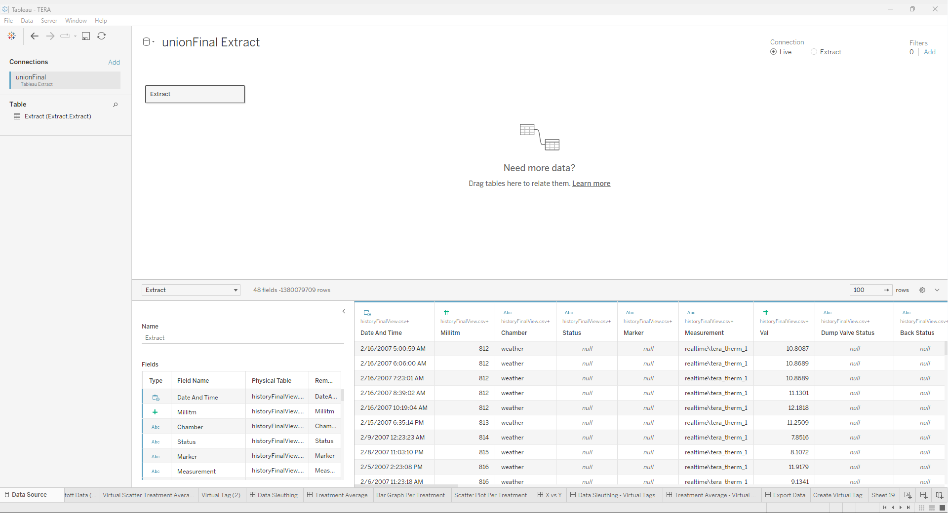

Switch your connection from live to extract:

Edit your extract by adding a filter for whichever column(s) you desire: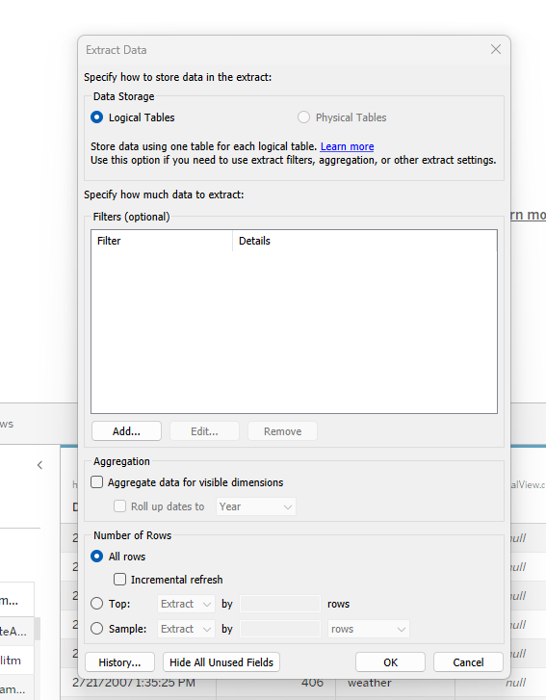

For the selected filter, choose all of the values you wish to keep in your extract: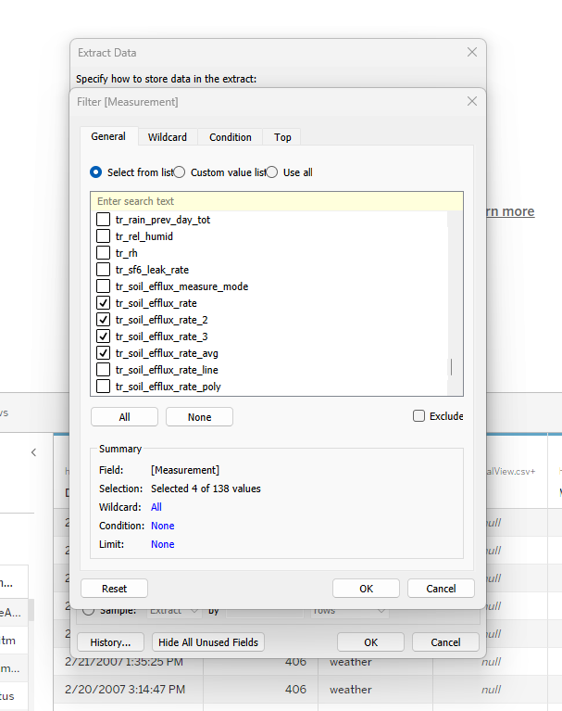

To filter by time, add another filter, choose ‘Date And Time’, and select ‘Range of Dates’: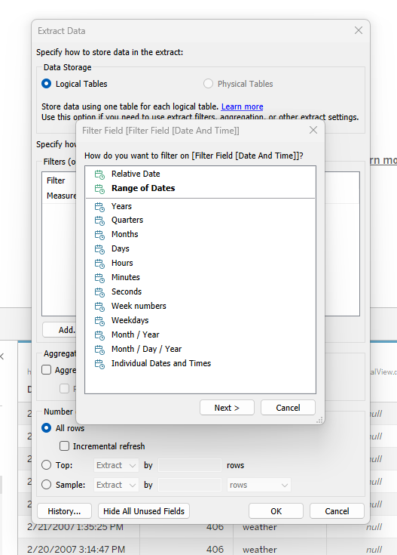

Adjust the selected date range to find a balance between speed and breadth of data. Starting small (a month to a year) and then gradually expanding the range as you assess the performance of your computer is a good way to go.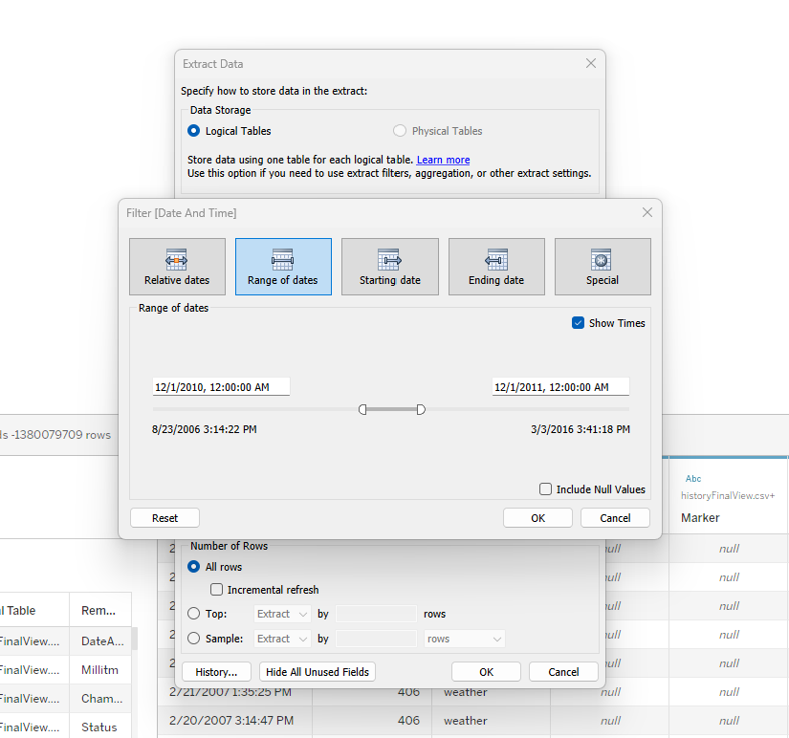

Once you’ve added all of the filters you’d like, press ok.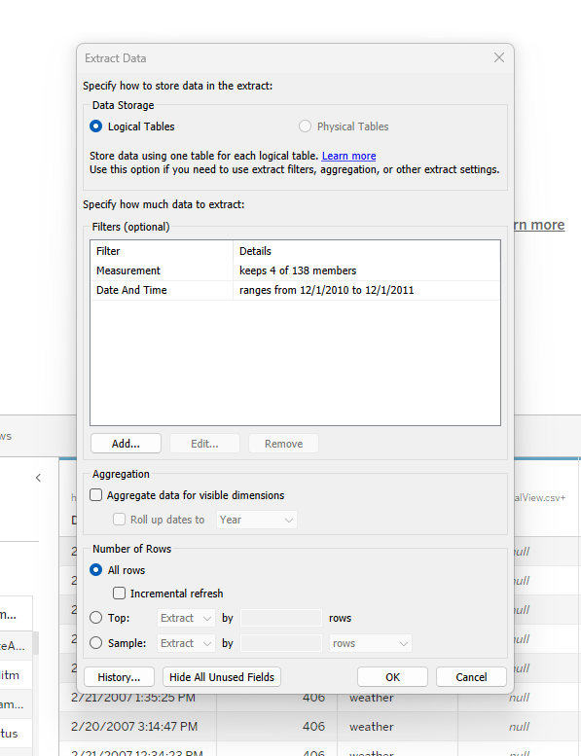

Lastly, to save your extract, click onto any of the other sheets in your workbook. Doing so will pop up a window that allows you to name your extract and choose where you’d like to save it.

